**USER MANUAL GUIDE**

This helps new user to operate the software created by me.

**The graphical Programming Language Application:**

**Open Form:**

After starting the project, the form is opened which is used for opening the next form for graphical design implementation.

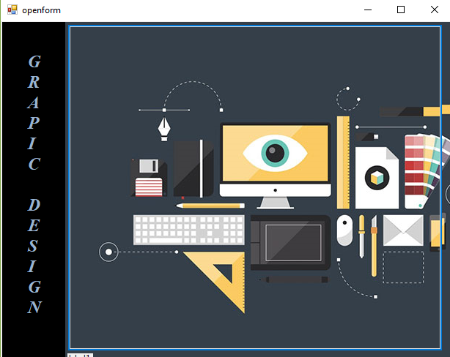

Click on the picture which is been used in button.

It display the form of graphical design implementation.

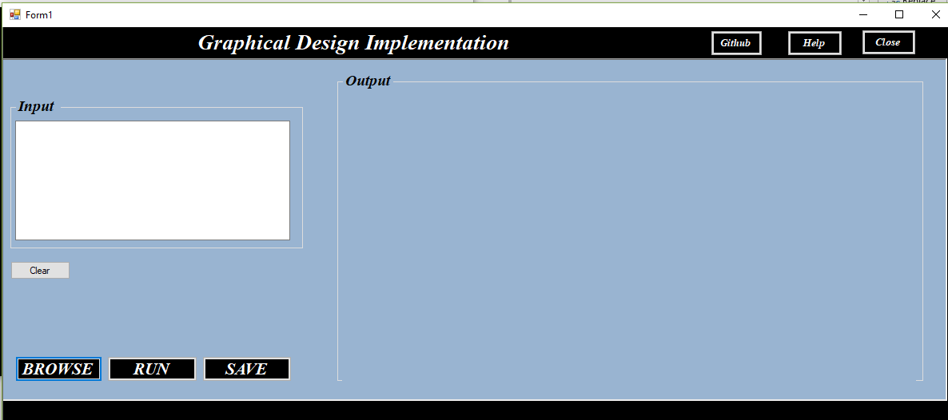

After then, we can draw shapes of triangle, rectangle, circle etc. by having the code in input textbox.

The result is been displayed in output box.

**Example:**

